FT-I Test
Academic Year: 2025-2026 (ODD Semester)

Program offered: M.Tech. (Automation & Robotics) Year / Sem: I / I
Course Code/Title: 21EIE551T: Computer Vision and Image Processing Date: 09.10.2025
Max. Marks: 40 Duration: 60 minutes

Course Articulation Matrix (CAM)

Course Outcomes (CO) | Program Outcomes (PO)
 | 1 | 2 | 3
CO1: Apply the knowledge to select the appropriate Robotic vision sensor and their interfacing. | 3
CO2: Ability to position, orientation and localization of objects using deep learning networks for solving tasks. | 3 |  | 2
CO3: Evaluate the performance of machine learning models using appropriate metrics and interpret the results of Robotic sensors. | 2 | 2 | 2

Answer any two questions (2*20 = 40 Marks)

S.No | Questions | CO | BL | Marks
1 | Apply the concept of camera calibration and demonstrate its influence on single-view geometry? | 1 | 3 | 20
2 | Given an image dataset with noise, use a stepwise filtering and restoration approach for robotic vision tasks. | 1 | 3 | 20
3 | Categorize the feature-based alignment and pose estimation techniques using suitable examples. | 2 | 4 | 20
4 | Illustrate the role of geometric error formulations (indirect vs. direct) in visual SLAM with examples. | 2 | 3 | 20

- Apply the concept of camera calibration and demonstrate its influence on single-view geometry?

Camera Calibration: (4 Marks)

Camera calibration is the process of estimating the parameters of a camera so that we can relate 3D points in the world to their corresponding 2D projections on the image plane. It removes distortions and provides a mathematical model of the camera.

Calibration involves finding two main types of parameters: (6 Marks)
(a) Intrinsic Parameters
- Internal to the camera.
- Define how the camera forms the image.
- Examples:
  - Focal length $(f_{x},f_{y})$
  - Principal point (image center)
  - Skew (non-rectangular pixels, usually negligible)
  - Lens distortion (radial, tangential)
(b) Extrinsic Parameters
- Define the pose of the camera with respect to the world.
- Includes:
  - Rotation matrix (orientation)
  - Translation vector (position)

Mathematical Model (4 Marks)

A point in 3D $[X,Y,Z]$is projected to the 2D image $[u,v]$using the pinhole camera model:
$$\left[\begin{matrix}u \\ v \\ 1\end{matrix}\right]=K \left[R ∣ t\right] \left[\begin{matrix}X \\ Y \\ Z \\ 1\end{matrix}\right]$$where:
- $K$= intrinsic matrix
- $[R∣t]$= extrinsic parameters
- Relation: World → Camera → Image

Why is Calibration Needed?
- Real cameras are not ideal (lens distortions, offset from image center, pixel scaling differences).
- Without calibration, 3D reconstruction, measurements, or mapping would be inaccurate.

Influence on Single-View Geometry (6 Marks)
- Single-view geometry refers to the geometric relationships (like projection, vanishing points, perspective effects) seen in an image taken from a single viewpoint.
- Calibration tells us the true mapping between scene geometry and its image.
- Effects:
  - Vanishing Points & Lines: Calibration determines how parallel lines in 3D converge to vanishing points in the image.
  - Metric Reconstruction: With calibration, we can measure real-world lengths, angles, and areas from a single image (not just projective geometry).
  - Camera Pose Estimation: Extrinsic calibration allows us to know where the camera is located in space relative to the scene.
  - Removing Distortion: Corrects curved lines (barrel/pincushion distortion) to recover accurate geometry.
- In short:
Without calibration → only projective geometry (relative structure, parallelism lost).
With calibration → metric geometry (true shapes, angles, measurements possible).

Example
- Show an image of a checkerboard pattern.
- Without calibration: edges appear curved, distances inaccurate.
- After calibration: edges are straight, geometry preserved.

- Given an image dataset with noise, use a stepwise filtering and restoration approach for robotic vision tasks.

1. Short introduction (2 marks)
Images acquired by robotic vision systems are corrupted by noise (sensor read noise, photon noise, compression artifacts) and degradations (blur from motion/defocus). A stepwise filtering + restoration pipeline improves downstream tasks (feature detection, localization, object recognition) by increasing SNR and restoring spatial details.

2. Overview of the proposed pipeline (2 mark)

- Data inspection & noise estimation
- Radiometric correction & normalization
- Outlier removal / salt-and-pepper handling
- Spatial denoising (edge-preserving)
- Frequency / transform-based denoising (if needed)
- Deblurring / inverse restoration
- Contrast enhancement & local tone correction
- Quality evaluation & parameter tuning

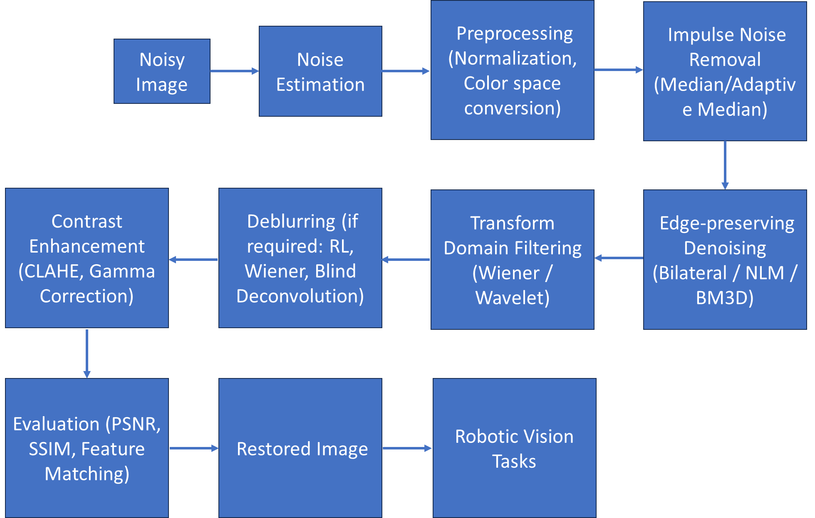

3. Detailed steps, techniques and rationale

Step 1 — Inspect data & estimate noise (2 mark)
- Compute sample statistics: mean, variance, histogram, and patch-based local variance.
- Estimate noise model: Gaussian (read noise), Poisson (photon noise), or impulse (salt-and-pepper).
- Simple estimator for Gaussian noise σ: take multiple flat patches or use robust median absolute deviation (MAD) on wavelet high-frequency coefficients:
$$σ≈\frac{\text{median}(∣W∣)}{0.6745}$$
where $W$are wavelet detail coefficients.

Step 2 — Radiometric correction & normalization (1 mark)
- Subtract bias/dark frame if available, divide by flat-field to correct vignetting.
- Normalize intensities (0–1 or 0–255). Convert to grayscale if color not needed for downstream tasks.
- If using color, operate in a perceptual space (e.g., YCbCr) and denoise luminance (Y) primarily.

Step 3 — Handle impulse / salt-and-pepper noise (1 mark)
- Use median filter (window 3×3 or 5×5) or adaptive median to remove isolated spikes while preserving edges.
- Adaptive median increases window until median differs from boundary values, good for variable densities.

Step 4 — Edge-preserving spatial denoising (2 marks)
- Bilateral filter (good baseline): preserves edges via spatial & range kernels.
$$I_{\text{out}}(p)=\frac{1}{W_{p}}\sum_{q}{I(q)exp⁡(-\frac{∥p-q∥^{2}}{2σ_{s}^{2}})exp⁡(-\frac{∣I(p)-I(q)∣^{2}}{2σ_{r}^{2}})}$$
  - Tune $σ_{s}$(spatial) and $σ_{r}$(intensity).
- Non-Local Means (NLM): averages patches weighted by patch similarity; good for textured regions.
- BM3D (Block-Matching and 3D filtering): state-of-the-art classical method — groups similar patches and does collaborative filtering in transform domain. Use when high-quality denoising is required.

Step 5 — Transform / frequency-domain denoising (1 mark)
- Wiener filter for additive Gaussian noise and known blur:
$$H(u,v): \hat{F}(u,v)=\frac{H^{*}(u,v)}{∣H(u,v)∣^{2}+S_{n}/S_{f}}G(u,v)$$
- Wavelet shrinkage / soft-thresholding: decompose image, threshold high-frequency coefficients. Threshold can be universal: $T=σ\sqrt{2log⁡N}$.
- Use transform denoising when noise is broadband and structural details are preserved by patch methods.

Step 6 — Image restoration (deblurring) (1 mark)
- If blurry (motion or defocus), estimate blur PSF then deconvolve:
  - Blind deconvolution (estimate PSF + image): iterative algorithms (e.g., alternating minimization).
  - Wiener deconvolution if PSF is known/estimated.
  - Richardson–Lucy: iterative maximum-likelihood deconvolution for Poisson noise.
- Regularize to avoid noise amplification — e.g., total variation (TV) regularization:
$$\underset{x}{min⁡}∥Hx-y∥_{2}^{2}+λTV⁡(x)$$
Step 7 — Contrast / local tone correction (1 mark)
- Apply contrast-limited adaptive histogram equalization (CLAHE) on luminance to avoid boosting noise.
- Gamma correction if camera response is nonlinear.

Step 8 — Final cleanup & morphological ops (1 mark)
- Use small morphological opening/closing to remove tiny residual artifacts in binary/mask tasks.
- Sharpening: unsharp mask with small radius and low strength if slight sharpening is required.

4. Evaluation metrics & verification (3 marks)
- PSNR (Peak Signal-to-Noise Ratio) — easy but doesn’t match perceptual quality.
- SSIM (Structural Similarity Index) — better for perceived quality.
- MSE (Mean Squared Error) — basic indicator.
- Edge preservation index / Gradient similarity — to verify features used by robotic vision (e.g., Harris corners).
- Task-level metrics: detection accuracy, feature matching score, localization error — ultimately these matter most for robotic tasks.
- Always evaluate on held-out test images and, where possible, with ground-truth clean images or synthetic noise added to clean images.

5. Practical implementation notes & parameter selection (3 marks)
- Start with automatic noise estimation, then:
  - For low Gaussian noise (σ < 10 on 0–255): bilateral / small Gaussian + NLM.
  - For moderate-to-high noise: BM3D or deep-learning denoisers (DnCNN, FFDNet) if resources allow.
- Trade-offs:
  - Bilateral/NLM: slower on large images — use fast approximations or downsample for parameter search.
  - BM3D: excellent quality; more complex to implement but available in libraries.
- Implementation libraries: OpenCV (median, bilateral, fast nonlocal means), scikit-image (denoise_nl_means), BM3D packages, PyTorch/TensorFlow for DL denoisers.
- For real-time robotic vision: use fast filters (guided filter, fast bilateral, approximate NLM) or run heavy denoising on a GPU.

